**[](http://www.google.com/url?sa=i&rct=j&q=&esrc=s&source=images&cd=&cad=rja&uact=8&ved=2ahUKEwit1afE_6XhAhXM6Y8KHQ6MBQoQjRx6BAgBEAU&url=/url?sa%3Di%26rct%3Dj%26q%3D%26esrc%3Ds%26source%3Dimages%26cd%3D%26ved%3D%26url%3Dhttps://photohendriksgalleries.com/categories/narrogin-senior-high-school%26psig%3DAOvVaw31aJ82acI2GYdGmPsE5cZ8%26ust%3D1553902359813612&psig=AOvVaw31aJ82acI2GYdGmPsE5cZ8&ust=1553902359813612)**

**Source Analysis Two**

**Question/Answer Booklet**

ATAR Name:

MODERN

HISTORY

**Unit 1**

Capitalism – The American Experience 1907-1941

1. Compare and contrast the messages of **Sources 1** and **2**. (4 marks)

Hint: What does the creator want you to think, feel or believe for each of the sources? (1 mark each for stating the message of each of the sources) What is similar about the sources? (1 mark) What is different about the sources? (1 mark)

________________________________________________________________________________________________________________________________________________________________________________________________________________________________________________________________________________________________________________________________________________________________________________________________________________________________________________________________________________________________________________________________________________________________________________________________________________________________________________________________________________________________________________________________________________________________________________________________________________________________________________________________________________________________________________________________________________________________________________________________________________________________________________________________________________________________________________

1. Evaluate the usefulness, in terms of strengths and weaknesses, of **Sources 1** and **2** in relation to the attitudes regarding Franklin D. Roosevelt’s responses to the Great Depression. (5 marks)

Hint: Give a judgement on whether the two sources teaches us anything attitudes regarding Franklin D. Roosevelt’s responses to the Great Depression. Provide examples of Source 1 as a representation of attitudes regarding Franklin D. Roosevelt’s responses to the Great Depression. (2 marks). Provide examples of Source 2 as a representation of attitudes regarding Franklin D. Roosevelt’s responses to the Great Depression. (2 marks). Evaluate the usefulness of the sources, is this evidence that tells us what it was like in the period? (1 mark).

____________________________________________________________________________________________________________________________________________________________________________________________________________________________________________________________________________________________________________________________________________________________________________________________________________________________________________________________________________________________________________________________________________________________________________________________________________________________________________________________________________________________________________________________________________________________________________________________________________________________________________________________________________________________________________________________________________________________________________________________________________________________________________________________________________________________________________________________________________________________________________________________________________________________________________________________________________________________________________________________________________________________________________________________________________________________________

1. Explain the historical context of **Source 3**. Include the relevant events, people and ideas depicted or represented in the source. (4 marks)

Hint: what, when, cause, effect? (1 mark each) Focus on what is in the source and explain the relevance/significance. What is the event/idea the source is directly related to, rather than the source itself? How did this affect society, what was the impact?

________________________________________________________________________________________________________________________________________________________________________________________________________________________________________________________________________________________________________________________________________________________________________________________________________________________________________________________________________________________________________________________________________________________________________________________________________________________________________________________________________________________________________________________________________________________________________________________________________________________________________________________________________________________________________________________________________________________________________________________________________________________________________________________________________________________________________________

1. Identify and account for the authors’ perspectives in **Sources 3** and **4** in relation to the attitudes regarding Franklin D. Roosevelt’s responses to the Great Depression. (6 marks)

Hint: What is the viewpoint of the creator? Articulate the perspective of Source 3 (1 mark). Articulate the perspective of Source 4 (1 mark). Analyse the perspectives in relation to the question asked which may include discussion of motives, bias, time, place, purpose (4 marks). What influenced the author/illustrator to create this? What were they hoping to achieve and why?

________________________________________________________________________________________________________________________________________________________________________________________________________________________________________________________________________________________________________________________________________________________________________________________________________________________________________________________________________________________________________________________________________________________________________________________________________________________________________________________________________________________________________________________________________________________________________________________________________________________________________________________________________________________________________________________________________________________________________________________________________________________________________________________________________________________________________________________________________________________________________________________________________________________________________________________________________________________________________________________________________________________________________________________________________________________________________________________________________________________________________________________________________________________________________________________________________________________________________________________________________________________________________________________________________________

1. Evaluate the extent to which the **four** sources give an accurate insight into the insight into the attitudes regarding Franklin D. Roosevelt’s responses to the Great Depression. (6 marks)

Hint: Make a judgement on how the four sources teach us about attitudes regarding Franklin D. Roosevelt’s responses to the Great Depression. Articulate the different attitudes that are shown (1 mark). Identify attitudes that have been omitted (1 mark). Evaluate the extent to which the sources reflect the different attitudes regarding Franklin D. Roosevelt’s responses to the Great Depression (3 marks).

________________________________________________________________________________________________________________________________________________________________________________________________________________________________________________________________________________________________________________________________________________________________________________________________________________________________________________________________________________________________________________________________________________________________________________________________________________________________________________________________________________________________________________________________________________________________________________________________________________________________________________________________________________________________________________________________________________________________________________________________________________________________________________________________________________________________________________________________________________________________________________________________________________________________________________________________________________________________________________________________________________________________________________________________________________________________________________________________________________________________________________________________________________________________________________________________________________________________________________________________________________________________

**End of Questions**

**Source Booklet**

**Source 1:** An American newspaper cartoonist’s view of the effects of Roosevelt’s policies, January 1934. The cartoon is entitled, The Sower’.

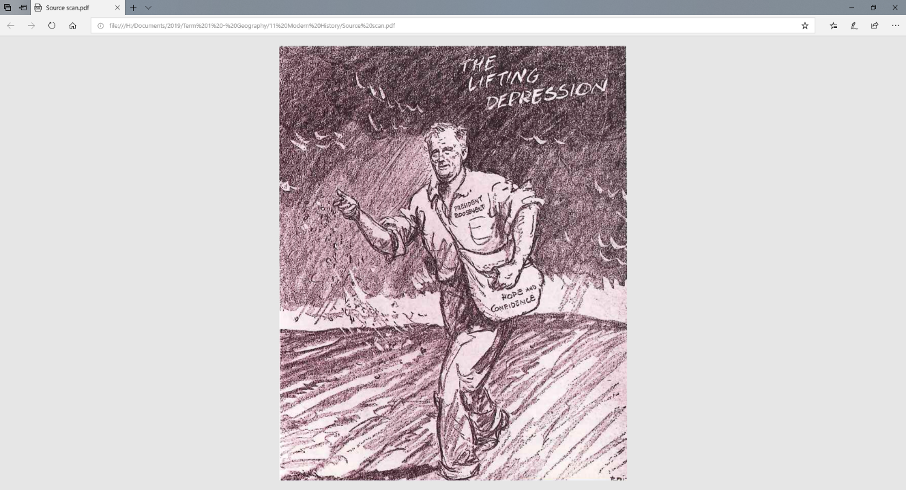

**Source 2:** A cartoon entitled ‘Priming the Pump’, published in an American newspaper in 1933.

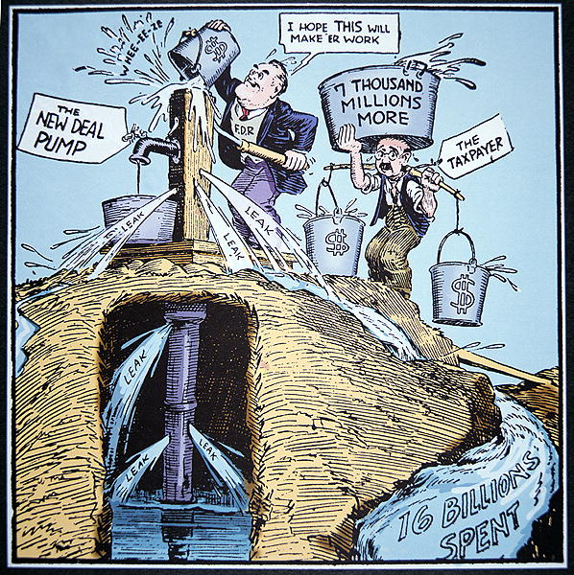

**Source 3:** A cartoon from the 1930s. The caption for this cartoon read, ‘Mother, Wilfred wrote a bad word’.